4.CREATE A SIMPLE CLOUD SOFTWARE APPLICATION FOR CAR BOOKING RESERVATION SYSTEM USING ANY CLOUD SERVICE PROVIDER TO DEMONSTRATE SAAS.

DATE: 17.11.2025
DAY: MONDAY

AIM:
To Create a simple cloud software application for Car Booking Reservation System using any Cloud Service Provider to demonstrate SaaS.

PROCEDURE:
step1: Go to zoho.com.
step 2: Log into the zoho.com.
step 3: Select one application step.
step4: Enter application name as Car Booking Reservation System.
step 5: Created new application as Car Booking Reservation System.
step 6: Select one form
step 7: The software has been created.

IMPLEMENTATION:
1.Customer Details
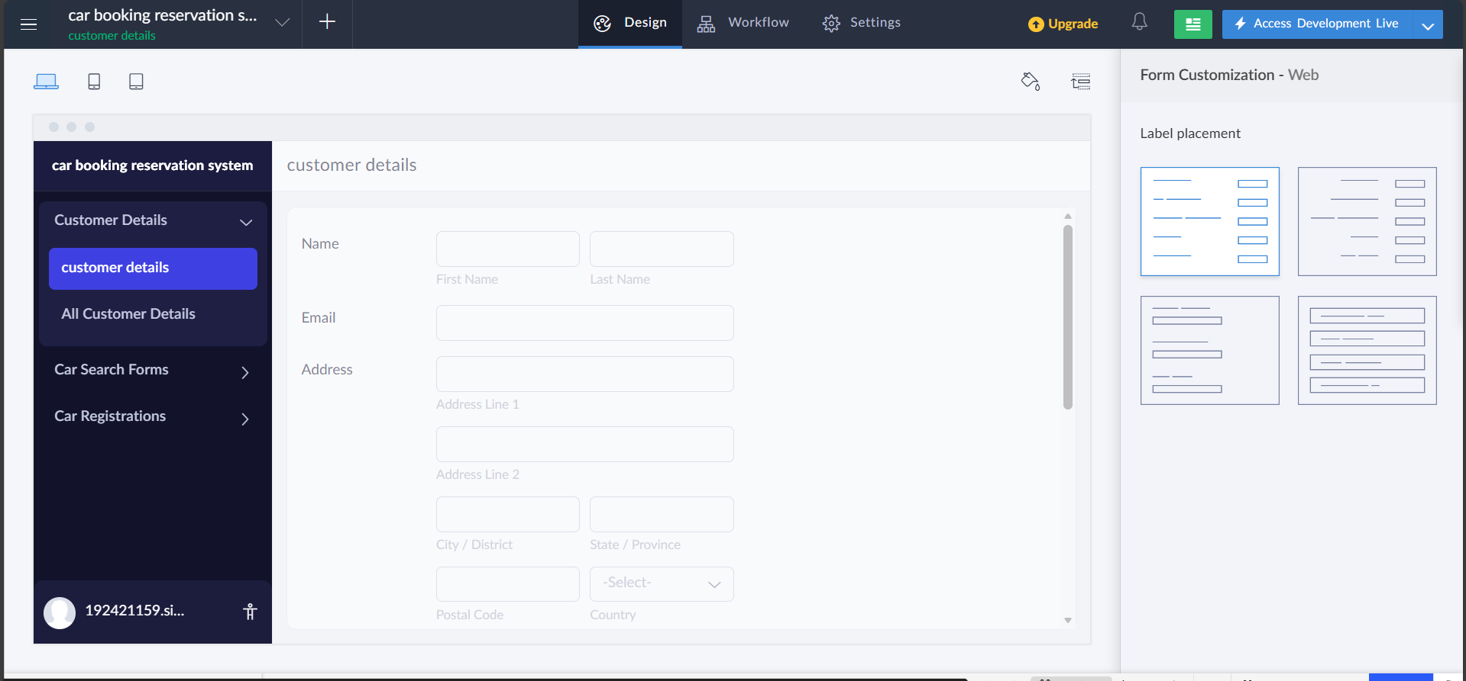

2.Car Search Form
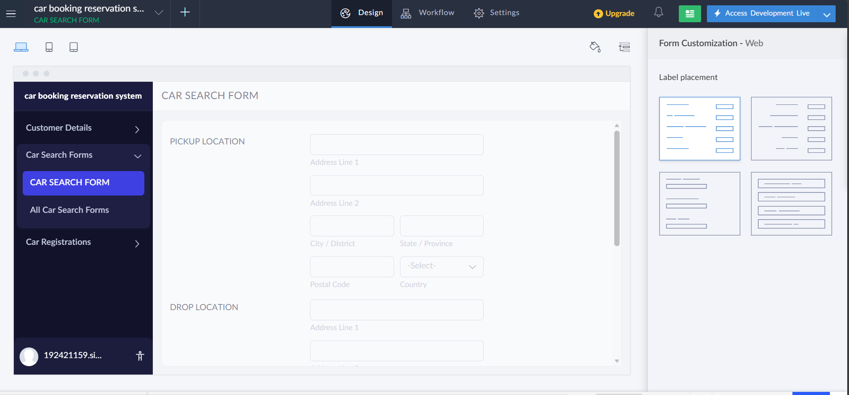

3.Car Registration
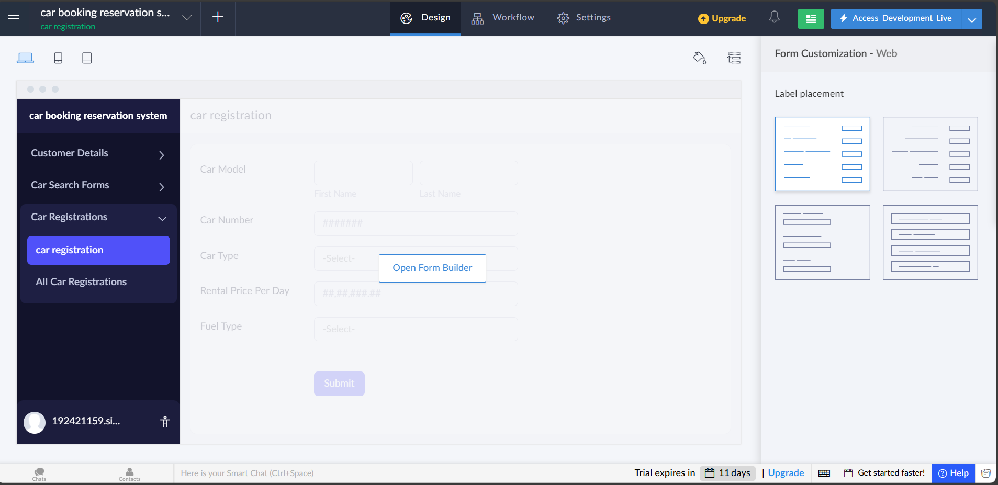

RESULT:
Successfully Created a simple cloud software application for CAR BOOKING REESERVATION SYSTEM.

